Configuring MTA-STS Using Cloudflare Workers
NB!!!
Any time the MX records are changed, this policy will need to be updated
The MX entry in the Cloudflare worker will need to be updated (Step 8), and the TXT record from step 20 will need to be updated if any changes are made.

- Sign into Cloudflare
- Click “Workers and Pages”
- Click “Create Application”
- Click “Create Worker”
- Specify the name as domain-tld-mta-sts
  - E.g. cloudboxtech-com-mta-sts
- Click “Deploy”
- Click “Edit Code”
- Clear the contents of the code-block window, and replace with the below:
async function handleRequest(request) {
const init = {
headers: {
'content-type': 'text/plain;charset=UTF-8'
},
}
return new Response(stsHTML, init)
}
addEventListener('fetch', event => {
return event.respondWith(handleRequest(event.request))
})
const stsHTML = `version: STSv1
mode: enforce
mx: vandaxasset-com.mail.protection.outlook.com
mx: mx2-eu1.ppe-hosted.com
mx: mx1-eu1.ppe-hosted.com
max_age: 604800
`
  - Substitute the highlighted MX entry for the Office 365 endpoint for that domain, and any other Mail Security Gateway MX servers.
- Click “Deploy”
- Click “Save and Deploy”
- Click the back arrow above the code block
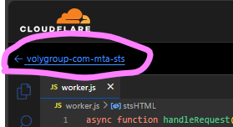
- Click “Settings”
- Under “Domains & Routes”
  - Click “+ Add”
  - Click “Custom Domain”
  - Type mta-sts.domain.com
  - Click “Add domain”
- Under Domains & Routes”
  - Click “+ Add”
  - Click Route
  - Select the Domain from the “Zone” Dropdown
  - Type “mta-sts.domain.com/.well-known/mta-sts.txt”
  - Click “Add route”
- Click “Websites” on the left-hand menu
- Search for the domain you’re currently working on
- Click the domain
- Click “DNS” on the left-hand menu
- For the first DNS Record:
  - Click “Add Record”
  - Set record type to “TXT”
  - Set name to _smtp._tls
  - Set content to v=TLSRPTv1; rua=mailto:smtptls@domain.tld
  - Click “Save”
- For 2nd DNS Record
  - Click “Add Record”
Set record type to “TXT”
  - Set name to _mta-sts
  - Set content to v=STSv1; id=YYYYMMDD
    - E.g. v=STSv1; id=20240516
  - Click “Save”
- Go to MTA-STS validator - Mailhardener tools
- Type in the name of the domain you were working on
- Click “Inspect”
- You should get the below output, bear in mind that delays in DNS propagation can cause this to fail.
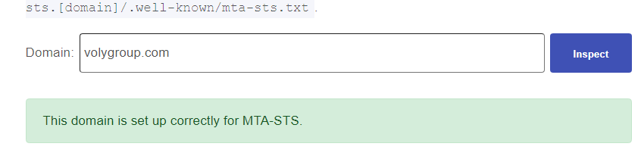
- If this fails, try again in about 30 mins
- If this still fails afterwards, troubleshooting can be done based on the outcome of this test.

